Assignment Lab 2
Names:

Problem 1:
People have higher levels of beta-endorphin in the blood under conditions of emotional stress. For 19 patients scheduled to undergo surgery, blood samples were taken (a) 12-24 hours before surgery and (b) 10 minutes before surgery. Beta-endorphin levels were measured in fmol/ml ( a femto-mole is 10⁻¹⁵ grams times the molecular weight of the substance). The data are as follows:

- 10.0 6.7 8.0 12.0 5.0 12.5 5.0 4.5 7.4 5.8 4.7 7.4 7.0 17.0 8.8 17.0 15.0 4.5 3.0
- 6.5 14.0 13.5 17.0 14.5 9.1 18.0 40.0 7.5 6.3 23.0 12.0 54.0 20.0 16.0 15.0 12.5 2.5 2.0

- Read the data into SAS, using DATALINES or INFILE (or both, for practice). Put the 12-24 hours before surgery measurements in one data set and the 10 minutes before surgery measurements in another data set. (include SAS code)
data stress1;
input levels @@;
datalines;
10.0 6.7 8.0 12.0 5.0 12.5 5.0 4.5 7.4
5.8 4.7 7.4 7.0 17.0 8.8 17.0 15.0 4.5 3.0
;
data stress2;
input levels @@;
datalines;
6.5 14.0 13.5 17.0 14.5 9.1 18.0 40.0 7.5 6.3 23.0
12.0 54.0 20.0 16.0 15.0 12.5 2.5 2.0
;
proc print data=stress1;
title 'Beta-endorphin levels 12-24 hours before surgery';
run;
proc print data=stress2;
title 'Beta-endorphin levels 10 minutes before surgery';
run;

- Print the data using PROC PRINT. Which data set is printed? Can you get both data sets to print?
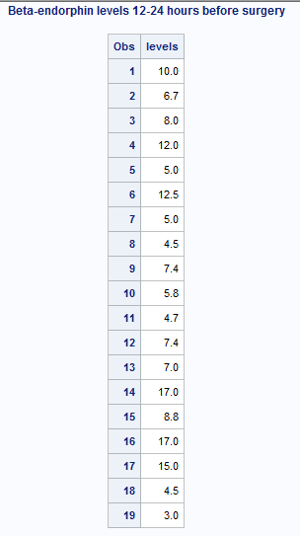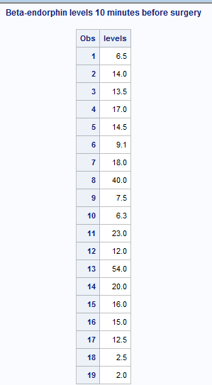
- Read the data into SAS again, this time into only one data set. (include SAS code)
data stress;
input levels time @@;
datalines;
10.0 1 6.7 1 8.0 1 12.0 1 5.0 1 12.5 1 5.0 1 4.5 1 7.4 1 5.8 1
4.7 1 7.4 1 7.0 1 17.0 1 8.8 1 17.0 1 15.0 1 4.5 1 3.0 1
6.5 2 14.0 2 13.5 2 17.0 2 14.5 2 9.1 2 18.0 2 40.0 2 7.5 2 6.3 2
23.0 2 12.0 2 54.0 2 20.0 2 16.0 2 15.0 2 12.5 2 2.5 2 2.0 2
;
proc print data=stress;
title 'Beta-endorphin levels';
run;

- Sort the data by the time the measurement was taken (12-24 hours or 10 minutes before surgery).
(include SAS code)
proc sort data=stress;
by time;
proc univariate plot data=stress;
by time;
var levels;
run;

- Use PROC UNIVARIATE to find the mean and median beta-endorphin level for each time period. Also, find the standard deviation and five-number summary for each time period.
Period 12-24 hour before surgery Period 10 minutes before surgery
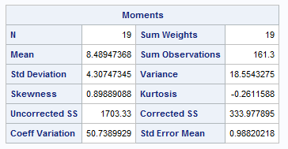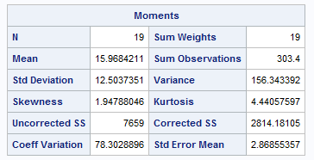
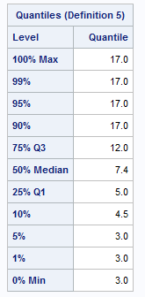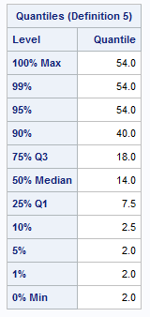

- Examine the box-plots of the beta-endorphin level for each time period. Which measures of center and spread should be used to describe these data? Why?
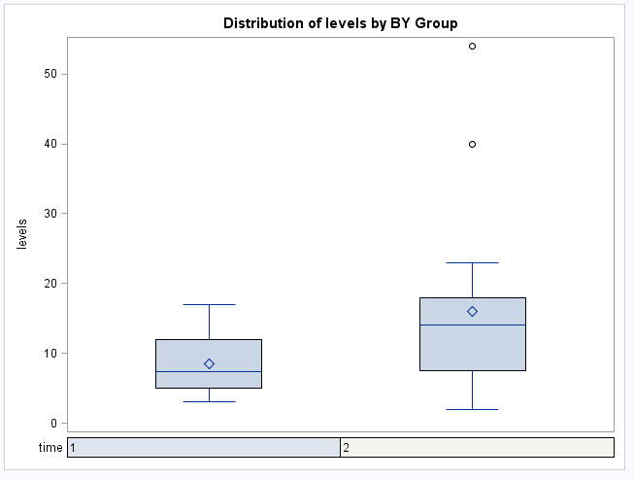

Both period shows that the mean is higher than the median. The mean of beta-endorphin level for 10 minutes before surgery is higher than the mean of beta-endoephin level 12-24 hours before surgery. Moreover, we can see that the beta-endorphin level for 10 minutes before surgery has a greater spread when compared to beta-endorphin level for 12-24 hours before surgery.

Problem 2:
The following data consists of mandible lengths in millimeters for 10 male and 10 female golden jackals. The first observation of each line of data is the mandible length for a male jackal, and the second observation in each line is the length for a female jackal.

Males: 107,110,112,113,114,114,115,116,117,120
Females: 105,106,107,108,109,110,110,111,111,113

- Read the data into two SAS data sets (one for males and one for females) using @ and the output statement. Print both data sets to the output window. Put a meaningful title on each data print-out.
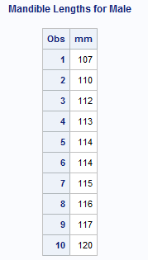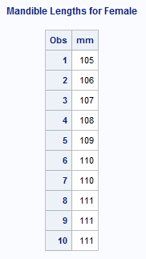

- Then use PROC UNIVARIATE to find the mean and standard deviation for male and female jackal lengths, and compare them to the five-number summaries we calculated in class. Put meaningful titles on the UNIVARIATE output. (BONUS: Calculate the mean and standard deviation for male jackal lengths BY HAND)
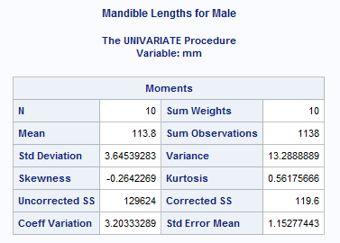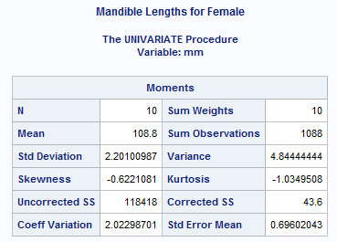
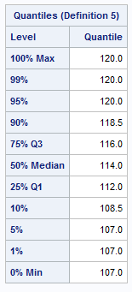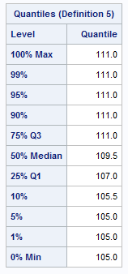
d
Problem 3:
Two different tablet brands are being compared based on the battery life performance. A longer lasting battery is a better brand. Both brands are tested by continually running movies until the battery dies. The amount of time a battery lasts per tablet (battery life) is the variable of interest (in hours). Eight tablets are chosen at random from each brand.
The data for battery life are as follows:
Tablet Brands
Apple iPad Air | Samsung Galaxy Tab
9.7 | 10.5
10.2 | 9.3
10 | 8.7
8.8 | 10.2
9.3 | 9.6

- By hand, find the means, variances and standard deviations of battery life separately for each brand. Interpret your result and verify your answers by using SAS.
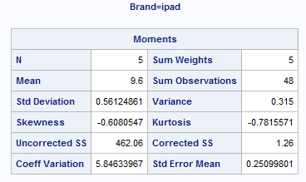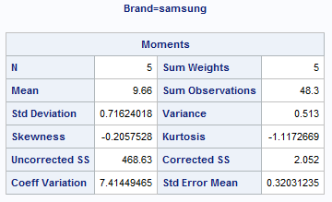

- Using SAS, generate a Stem and Leaf plot and a side-by-side Box-Whisker plot for both brands. Relate the plots to your results in (i).
iPad Samsung
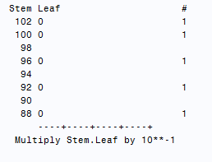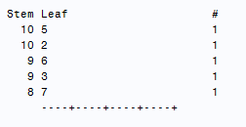
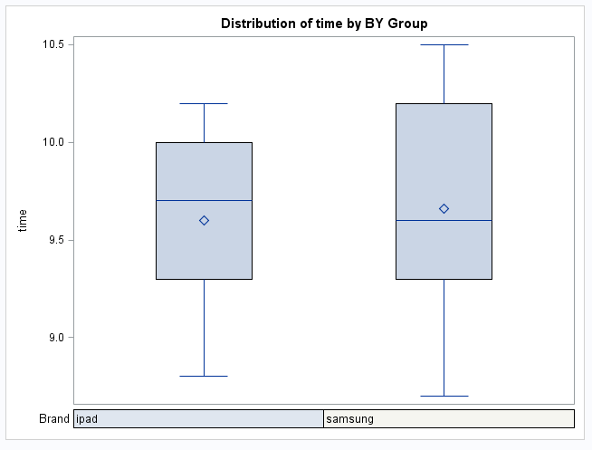
- Describe the skewness of the data. Are they symmetric? Skewed? If so how are they skewes? Positively-skewed or negatively-skewed.
Apple iPad is a left (negative) skewed data. The Samsung Galaxy tab has a right (positive) skewed data; the mean is pulled to the left towards the two higher outliers. Samsung Galaxy tab has a higher variance than Apple Ipad.

/*Problem 1*/
data stress1;
input levels @@;
datalines;
10.0 6.7 8.0 12.0 5.0 12.5 5.0 4.5 7.4
5.8 4.7 7.4 7.0 17.0 8.8 17.0 15.0 4.5 3.0
;
data stress2;
input levels @@;
datalines;
6.5 14.0 13.5 17.0 14.5 9.1 18.0 40.0 7.5 6.3 23.0
12.0 54.0 20.0 16.0 15.0 12.5 2.5 2.0
;
proc print data=stress1;
title 'Beta-endorphin levels 12-24 hours before surgery';
run;
proc print data=stress2;
title 'Beta-endorphin levels 10 minutes before surgery';
run;

data stress;
input levels time @@;
datalines;
10.0 1 6.7 1 8.0 1 12.0 1 5.0 1 12.5 1 5.0 1 4.5 1 7.4 1 5.8 1
4.7 1 7.4 1 7.0 1 17.0 1 8.8 1 17.0 1 15.0 1 4.5 1 3.0 1
6.5 2 14.0 2 13.5 2 17.0 2 14.5 2 9.1 2 18.0 2 40.0 2 7.5 2 6.3 2
23.0 2 12.0 2 54.0 2 20.0 2 16.0 2 15.0 2 12.5 2 2.5 2 2.0 2
;
proc print data=stress;
title 'Beta-endorphin levels';
run;
proc sort data=stress;
by time;
proc univariate plot data=stress;
by time;
var levels;
run;

/*Problem 2*/
data male;
input mm @@;
datalines;
107 110 112 113 114 114 115 116 117 120
;
proc print data=male;
title 'Mandible Lengths for Male';
run;
data female;
input mm @@;
datalines;
105 106 107 108 109 110 110 111 111 111
;
proc print data=female;
title 'Mandible Lengths for Female';
run;
proc univariate plot data=male;
title 'Mandible Lengths for Male';
var mm;
run;
proc univariate plot data=female;
title 'Mandible Lengths for Female';
var mm;
run;

/*Problem 3*/
DATA Data3;
INPUT Brand $ @;
DO I=1 TO 5;
INPUT time @;
OUTPUT;
END;
DATALINES;
ipad 9.7 10.2 10 8.8 9.3
samsung 10.5 9.3 8.7 10.2 9.6
;
RUN;
PROC PRINT DATA=Data3;
VAR brand time;
RUN;
PROC UNIVARIATE PLOT DATA=Data3;
VAR time;
RUN;
PROC SORT DATA=Data3 OUT=DATA4;
BY brand time;
RUN;
PROC PRINT DATA=Data4;
VAR brand time;
RUN;
ods graphics off;
PROC UNIVARIATE PLOT DATA=Data4;
VAR time;
BY brand;
RUN;
PROC BOXPLOT DATA=Data4;
PLOT brand*time;
RUN;

